Deutsch Goulash und Spätzle (Donald)

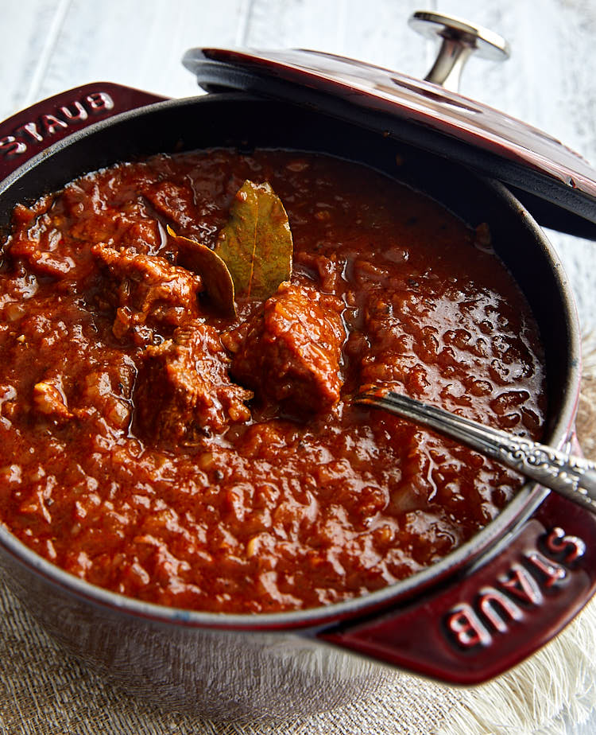
Ingredients
- 2 lbs yellow onions (about 6-8 medium onions)
- 4 Tbsp clarified butter (regular butter will work as well)
- 2 lbs lean beef (veal or trimmed chuck is best)
- 3 cloves garlic
- 1 tsp caraway seeds
- 2 tsp dried marjoram
- 2 Tbsp sweet paprika
- 2 Tbsp tomato paste
- 3 Tbsp red wine vinegar
- 1¾ cup beef broth
- 2 bay leaves
- 1 tsp kosher salt (plus more to taste)
- ¼ tsp ground black pepper (plus more to taste)

Instructions
  - Preheat the oven to 350°F if cooking in the oven as opposed to on the stove top.
  - Peel and chop the onions very finely. Set aside.
  - Heat the butter in a roasting pan over medium heat. Add the onions and cook, stirring frequently, until golden brown, about 30 minutes.
  - In the meantime, trim the beef of any fat and sinew, then cut the beef into about 1" - 1½" pieces. Set aside.
  - Peel the garlic, chop, add caraway seeds and mince together with a knife.
  - Once the onions are ready, add the beef broth, red wine vinegar, paprika and the meat together with the bay leaves, garlic, caraway seeds, marjoram, and tomato paste. Mix and bring to gentle simmer. Turn the heat down to low, cover and let simmer on the stove top (or in the oven at 350F) until the onions have mostly disintegrated and the beef is tender, about 90 minutes to 2 hours. For a thicker consistency, cook uncovered or partially covered after 1 hour while frequently checking on the progress. Once the goulash is thick enough for your taste, cover and continue cooking until done.
  - Season the goulash with salt and pepper, remove the bay leaves and serve while hot.
Bon Appétit

Spätzle (Egg Spaetzle Noodles)
https://www.recipesfromeurope.com/german-spaetzle-recipe/

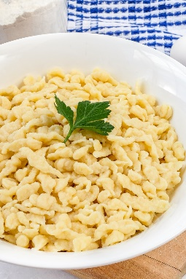
Ingredients
- 2 cups all-purpose flour
- 4 medium-sized eggs
- 1 teaspoon salt
- ½ cup water

Instructions
  - Add the flour to a medium-sized mixing bowl and make a little well (or a mini volcano) in the middle.
  - Add the eggs and the salt to the flour and give everything a stir with a wooden spoon or your electric mixer. Now slowly pour in the water while mixing vigorously until the dough has a lump-free, elastic consistency. When you roll the wooden spoon in the batter, you should be able to create air bubbles as a result of the sticky yet smooth consistency. Another way to tell that the batter has the right consistency is when it drips off the spoon very slowly.
  - Bring a large pot of salted water to a boil. Once boiling, reduce the heat so that the water is simmering.
  - Now, spoon portions of the Spaetzle batter onto your spaetzle grater/maker and scrape the batter through into the boiling water. The spaetzle will float to the top when they are done. This takes around 2-3 minutes.
  - Remove the little dumplings with a large straining spoon and place them into a different bowl. Repeat the steps until you have used up all the batter. Enjoy!

Notes
- This recipe makes approximately 4 ½ – 5 cups of egg noodles.
- You can also shock the Spaetzle noodles in cold water after you remove them from the pot and then reheat them in a frying pan with a bit of butter later if you don’t plan on eating them right away.
- If you know that you want to make cheese spaetzle (Kasespaetzle), you can sprinkle some grated Emmental cheese onto each batch of spaetzle after you take them out of the boiling water.
- We’d highly recommend using a proper spaetzle grater/maker but you can also make spaetzle by dropping bits of batter off a spoon into the boiling water using another spoon or knife. It’s tedious but it can work.
- As mentioned, Spaetzle taste great as cheese spätzle with a salad on the side, or as a side to meat dishes like goulash or rouladen.

